W-19
YEAR 10 SCIENCE (IEP)
PHYSICAL SCIENCE
TOPIC TEST
Name: Mark: $\frac{}{\text{17}}$

Part 1: Multiple Choice
MULTIPLE CHOICE ANSWERS
1
2
3
4
5
6

Write your choice for each question in the table below.

1. The crumple zone of a car is designed to:

(a) allow the vehicle and passengers to stop more slowly.
(b) decrease the time before the car comes to a stop after a collision.
(c) allow the chassis to bend.
(d) create a reaction force that equals the action force.

2. The rate of change of speed of an object is known as:

(a) average speed.
(b) average velocity.
(c) change in velocity.
(d) acceleration.

3. Newton’s law, known as the law of inertia, is:

(a) his first law.
(b) his second law.
(c) his third law.
(d) none of the above.

4. The tendency of an object to try to stay still when a force is applied to it is called:

(a) inertia.
(b) weight.
(c) friction.
(d) work.

5. The force of gravity acting on an object is called:

(a) inertia.
(b) weight.
(c) friction.
(d) work.

6. In the diagram below, the arrows show the size and direction of two force arrows acting on the bike.

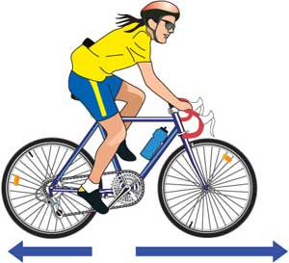

Which of the following describes the effect of the pair of forces on the bike?

(a) The bike will slow down.
(b) The force forwards is bigger that the force backwards.
(c) The bike will remain stationary.
(d) The two forces are equal.

Part 2: Short Answer

1. What happens to a ball placed on the middle of the back seat of a car in the following situations. Which way does it move?

(a) The car brakes suddenly. (1 mark)

(b) The car turns right. (1 mark)

(c) The car accelerates. (1 mark)

2. On Earth, you have a particular weight value measured in Newtons.

e.g. A person of 60 kg has a weight of about 600 N.

If you go to the Moon, gravity is different and you will have a different weight.

CIRCLE THE BEST ANSWER BELOW.

• Your weight on the Moon would:

(a) increase.

(b) decrease.

(c) stay the same. (1 mark)

3. In the diagram below, calculate the resultant force that is acting and its direction.

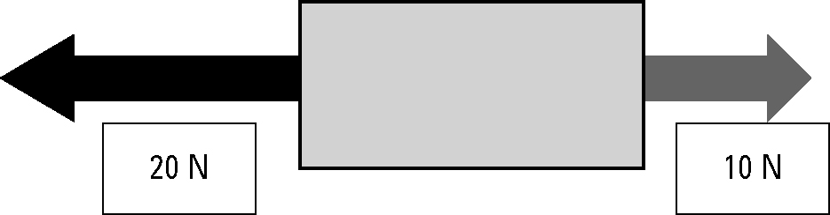

Resultant force: N

Direction: (2 marks)

4. A 1.0 kg pendulum is mounted on the roof of a vehicle as shown in the diagram.
(2 marks)

5. Graph the following data. (3 marks)

